

Compiler Construction Lab

Name: Kashaf Ahmad
Sap ID: 53155
Submitted To: Ma`am Hasnat Bibi

Riphah International University, Islamabad
Task 1:
#include <iostream>
using namespace std;
string input;
int i = 0;
void S() {
if (input[i] == 'a') {
i++;
S();
if (input[i] == 'b') {
i++;
} else {
cout << "Error\n";
exit(0);
}
}
}
int main() {
cout<<"Enter string:";
cin >> input;
S();
if (i == input.length())
cout << "String Accepted\n";
else
cout << "String Rejected\n";
}
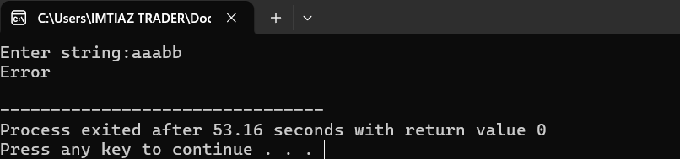
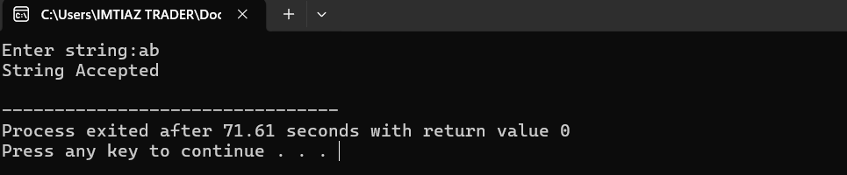

Task 2:
#include <iostream>
#include <string>
using namespace std;

string input;
int i = 0;

// Function declarations
void E();
void Eprime();
void T();
void Tprime();
void F();

// Match function
void match(char expected) {
if (input[i] == expected) {
i++;
} else {
cout << "Syntax Error\n";
exit(0);
}
}

// E --> T E'
void E() {
T();
Eprime();
}

// E' --> - T E' | e
void Eprime() {
if (input[i] == '-') {
match('-');
T();
Eprime();
}
}

// T --> F T'
void T() {
F();
Tprime();
}

// T' --> * F T' | e
void Tprime() {
if (input[i] == '*') {
match('*');
F();
Tprime();
}
}

// F --> i | (E)
void F() {
if (input[i] == 'i') {
match('i');
}
else if (input[i] == '(') {
match('(');
E();
match(')');
}
else {
cout << "Syntax Error\n";
exit(0);
}
}

// Main function
int main() {
cout << "Enter expression: ";
cin >> input;

E();

if (i == input.length())
cout << "String Accepted\n";
else
cout << "String Rejected\n";

return 0;
}

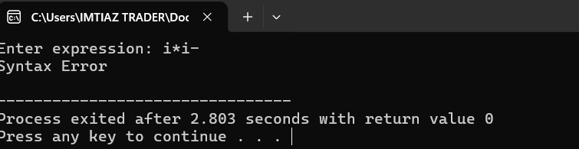
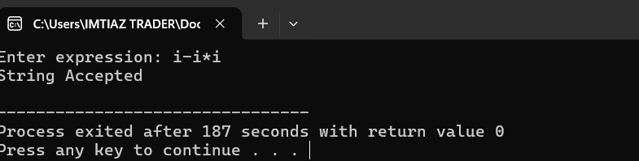

Task 3:
#include <iostream>
#include <string>
using namespace std;

string input;
int i = 0;

void E();
void Eprime();
void T();
void Tprime();
void F();

void error() {
cout << "Syntax Error\n";
exit(0);
}

// E --> T E'
void E() {
T();
Eprime();
}

// E' --> + T E' | - T E' | e
void Eprime() {
if (input[i] == '+') {
i++;
T();
Eprime();
}
else if (input[i] == '-') {
i++;
T();
Eprime();
}
}

// T --> F T'
void T() {
F();
Tprime();
}

// T' --> * F T' | / F T' | e
void Tprime() {
if (input[i] == '*') {
i++;
F();
Tprime();
}
else if (input[i] == '/') {
i++;
F();
Tprime();
}
}

// F --> id | (E)
void F() {
if (input.substr(i, 2) == "id") {
i += 2;
}
else if (input[i] == '(') {
i++;
E();
if (input[i] == ')')
i++;
else
error();
}
else {
error();
}
}

int main() {
cout << "Enter expression: ";
cin >> input;

E();

if (i == input.length())
cout << "String Accepted\n";
else
cout << "String Rejected\n";

return 0;
}

